- Original Data Flow Diagram
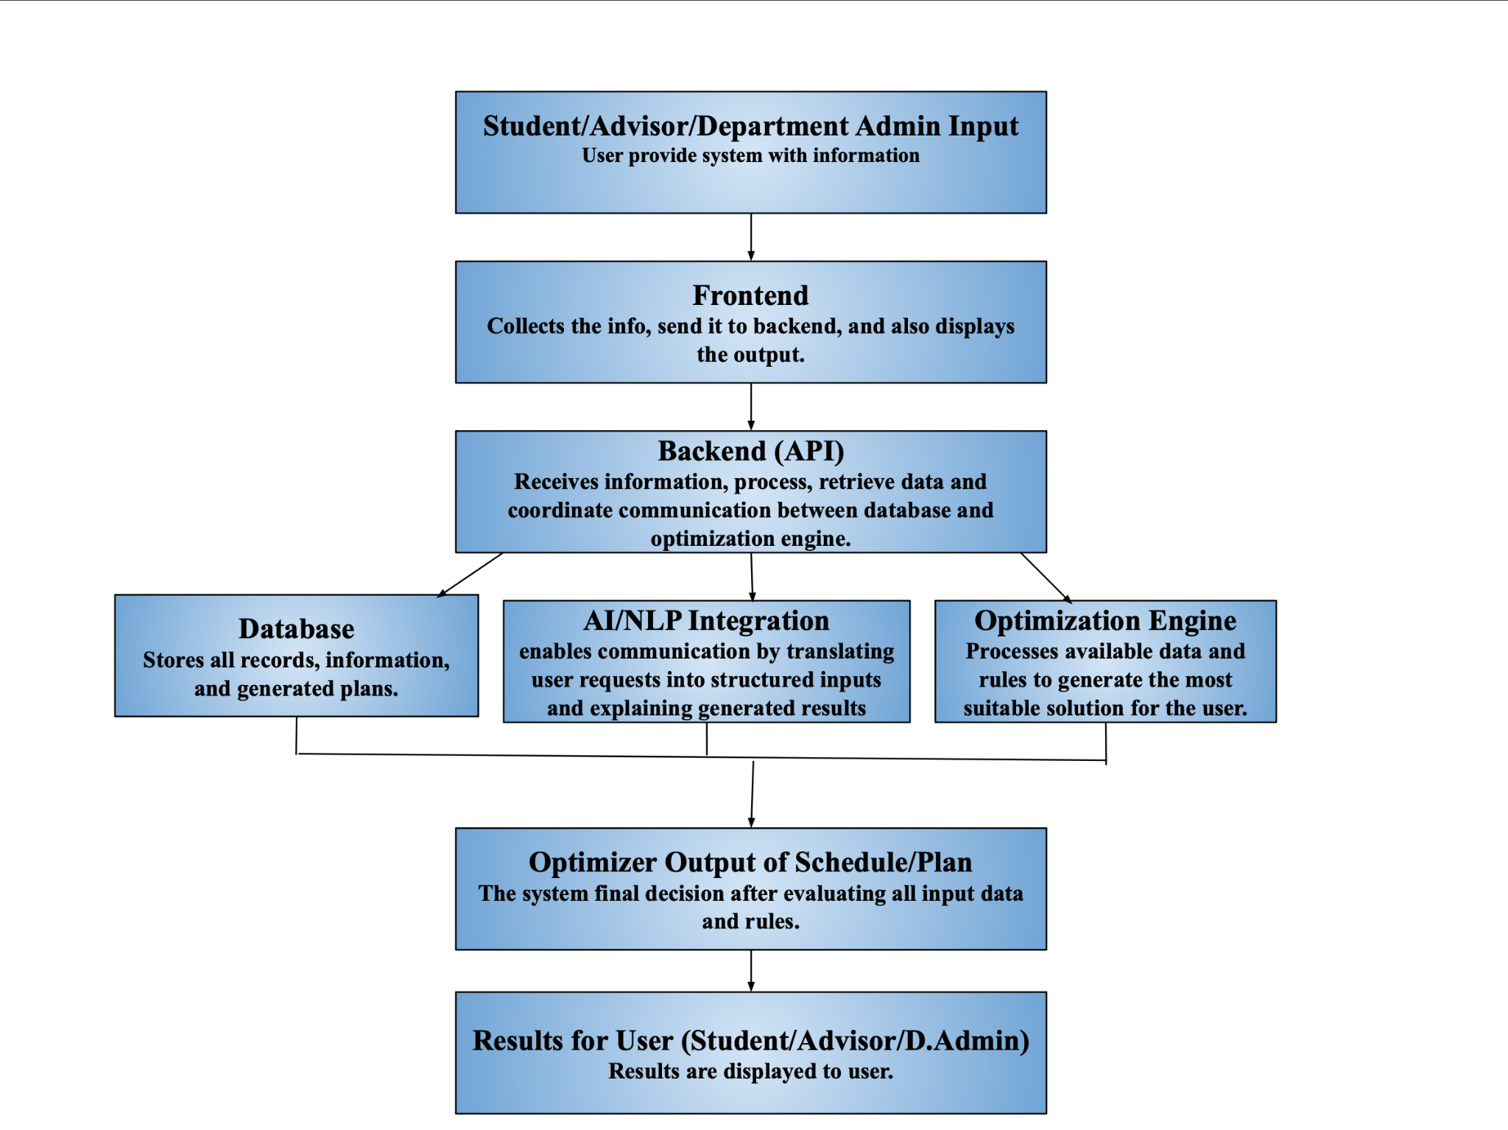

- Detailed Data Flow Diagram based on information of IAPO with Chat AI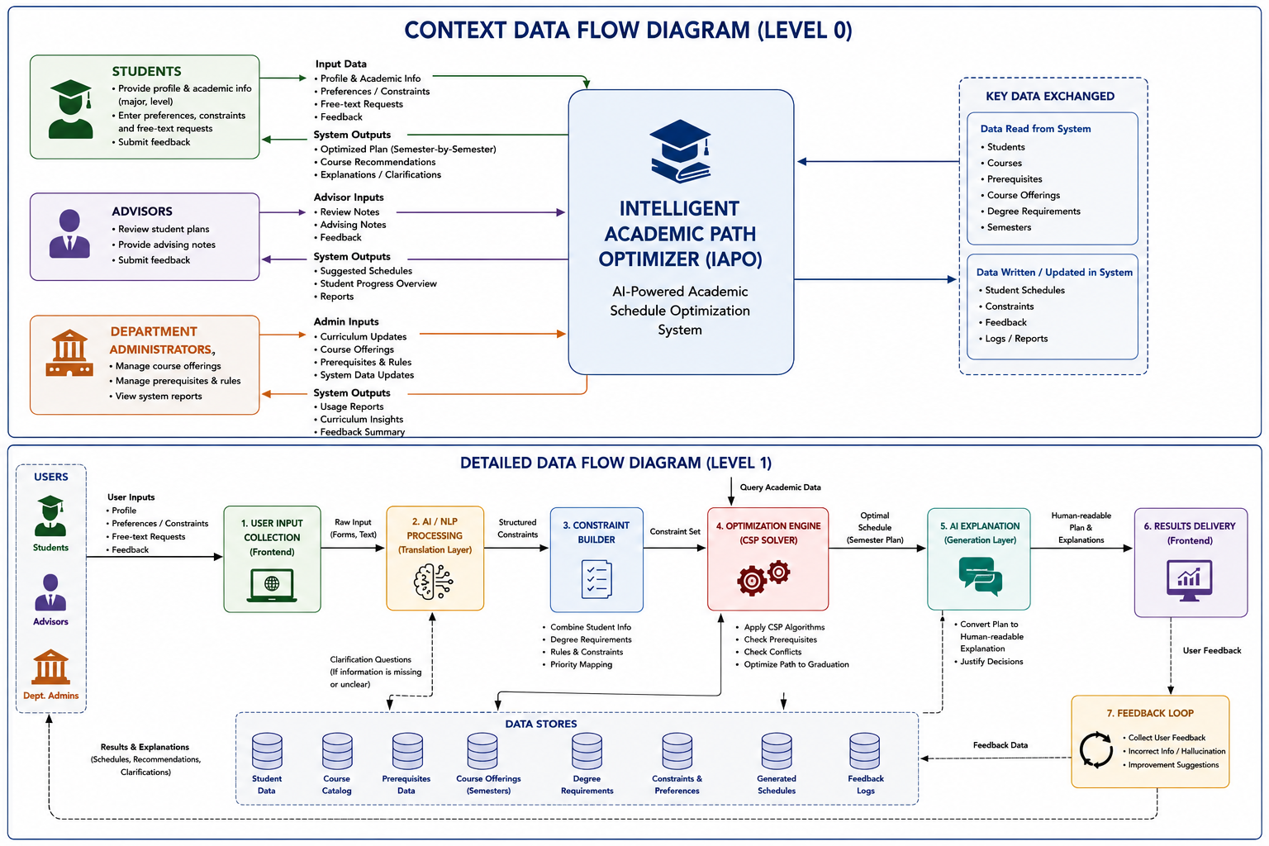

- Entity Relationship (ER) Diagram using Claude AI from original Dbeaver diagram
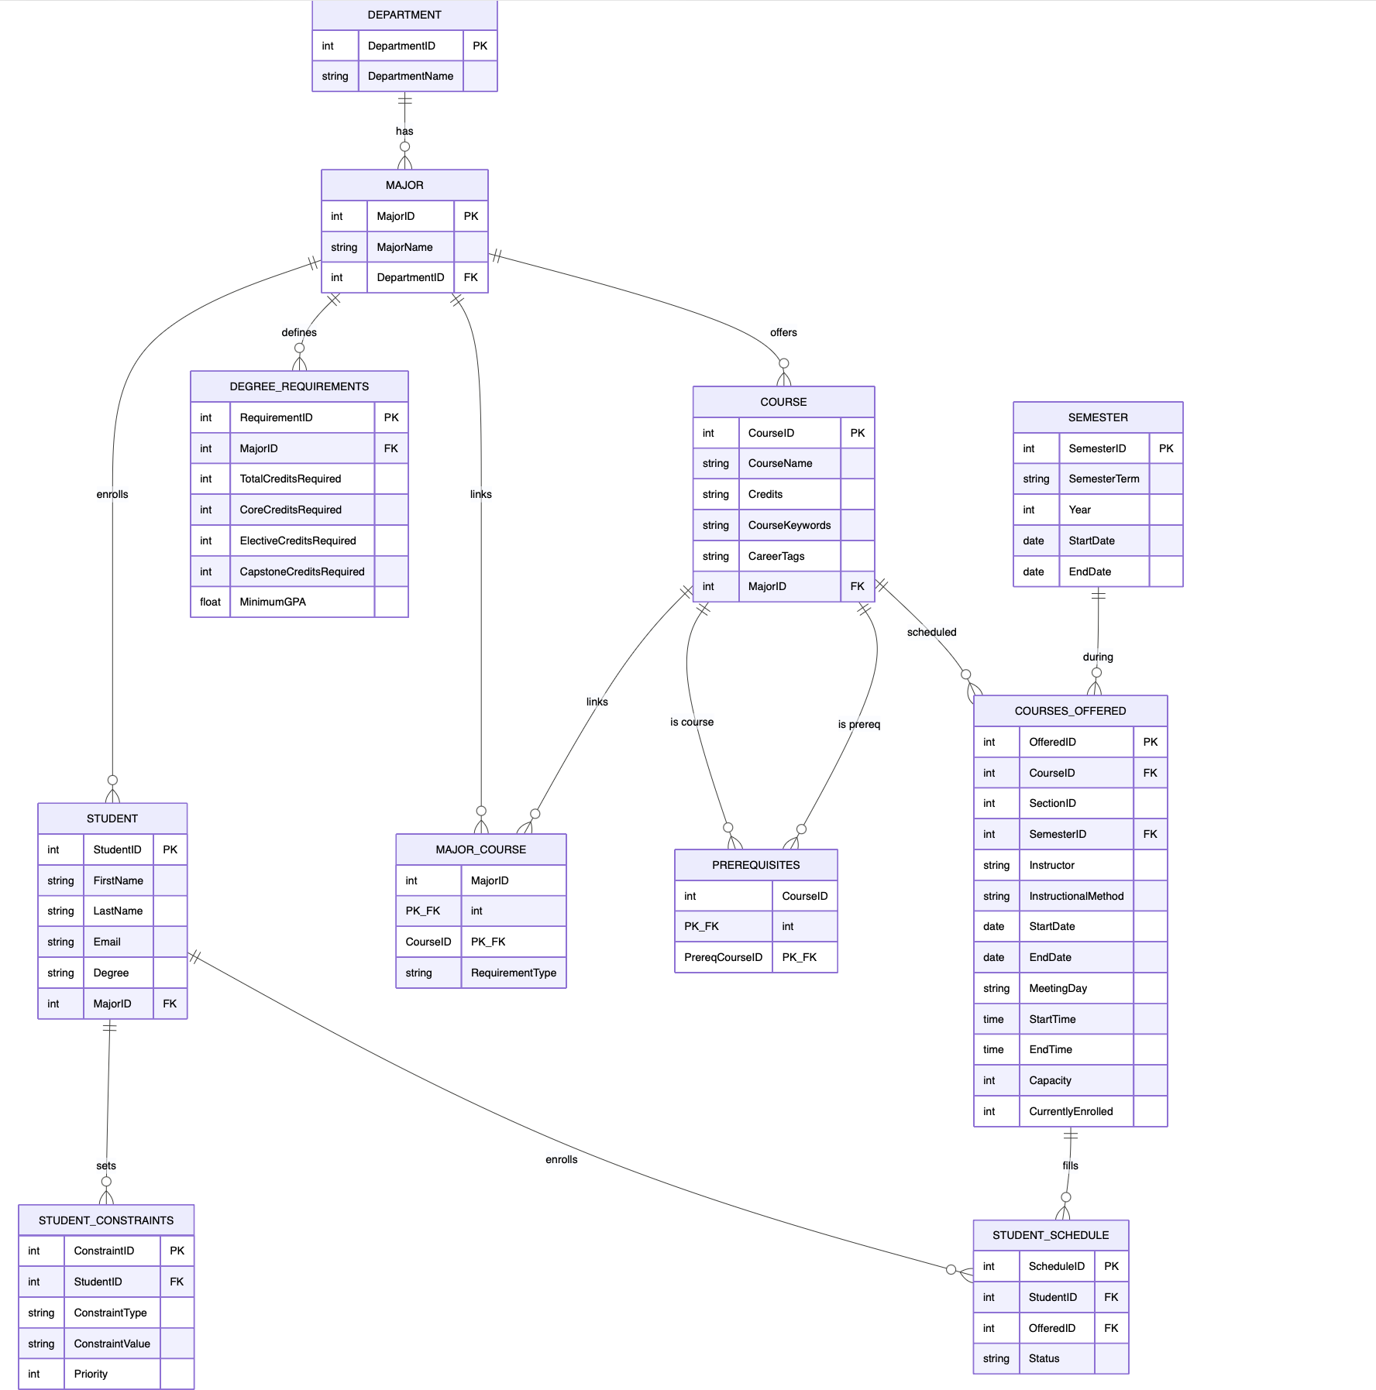
- Systems Architecture (both original & updated)
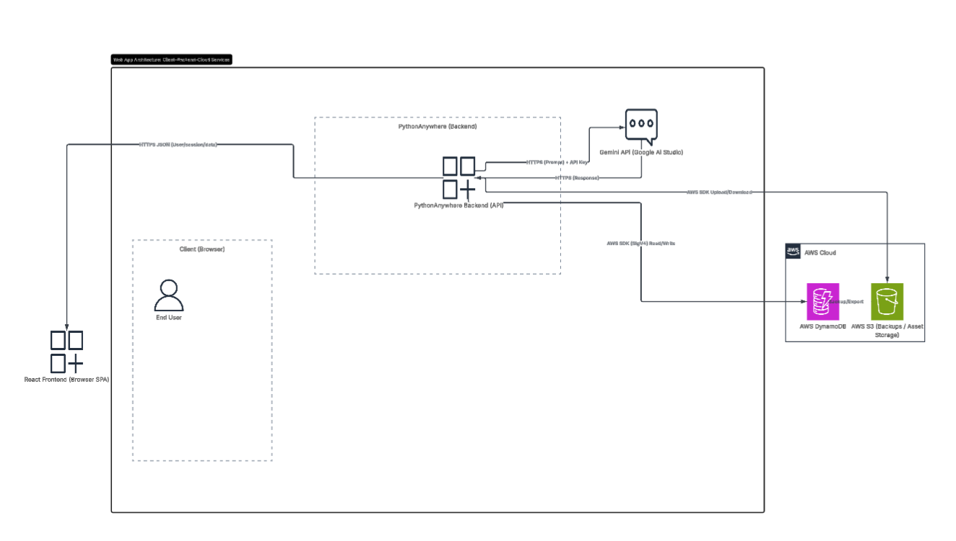
- Updated

